**“UNIVERSIDAD DE LAS FUERZAS ARMADAS - ESPE”**

**OBJECT-ORIENTED PROGRAMMING**

**Members**

* Karla Cajas
* Carlos Campoverde
* Myckel Chamorro
* Esteban Chablay

**NRC**: 3092

**ERRORS DURING PROGRAM EXECUTION**

1.-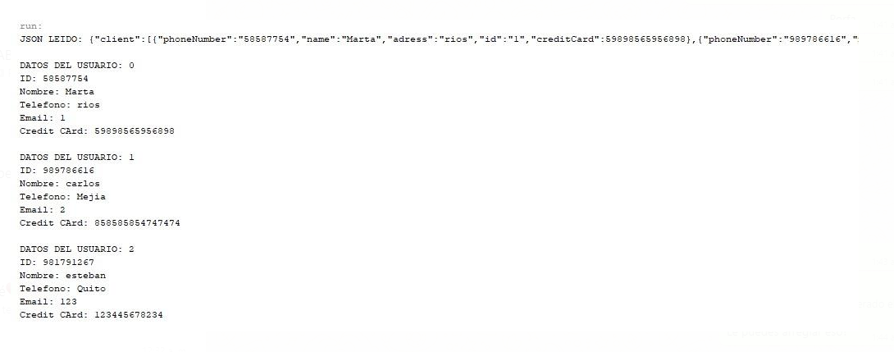

* Dirty code 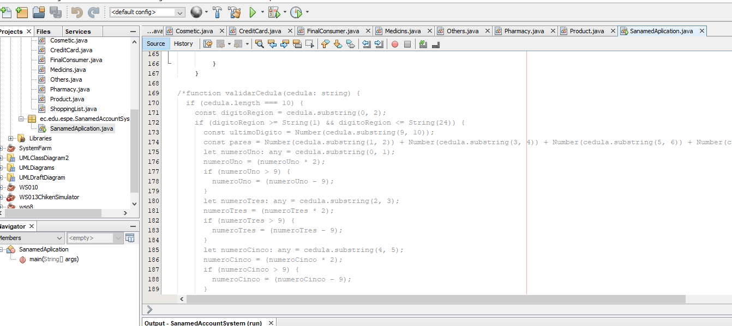
* Many comments while coding

2.-

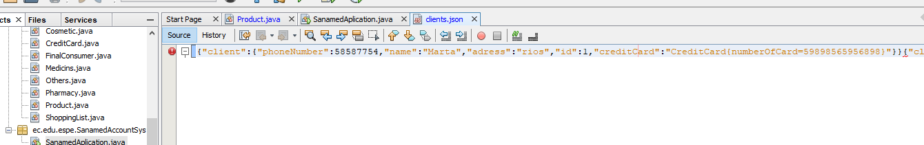

* credicard is defined as an object

3.-

* Bad generation of the json file to be able to modify it or delete information

4.-

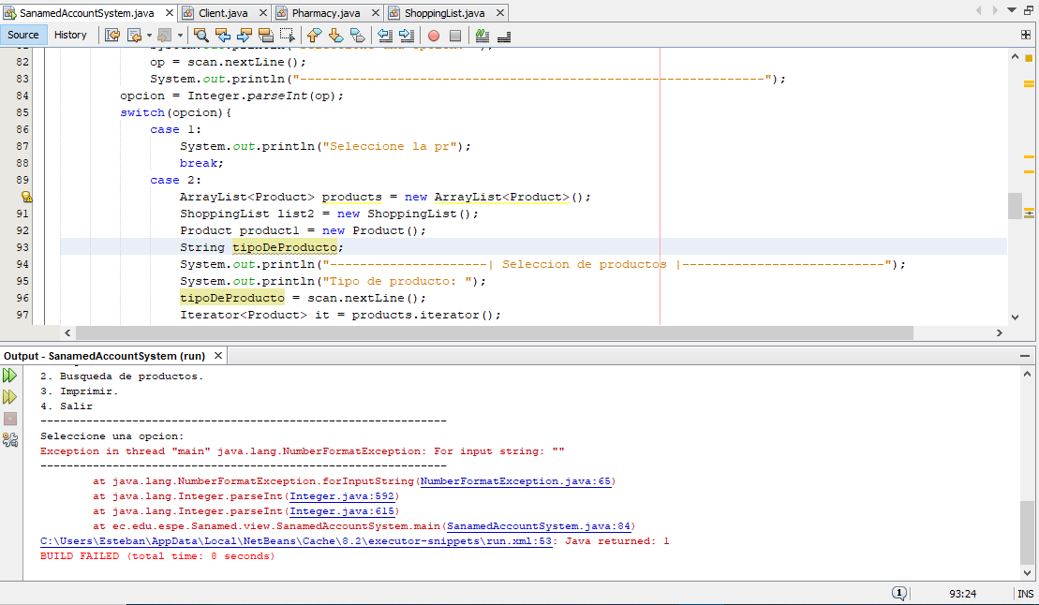

* Having the array empty produces this error

5. -

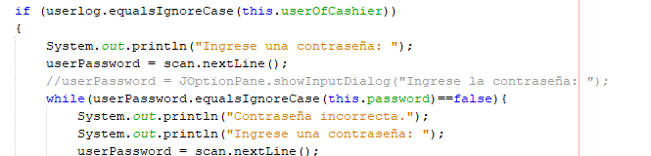

* Login by user and password is not case sensitive.

6.-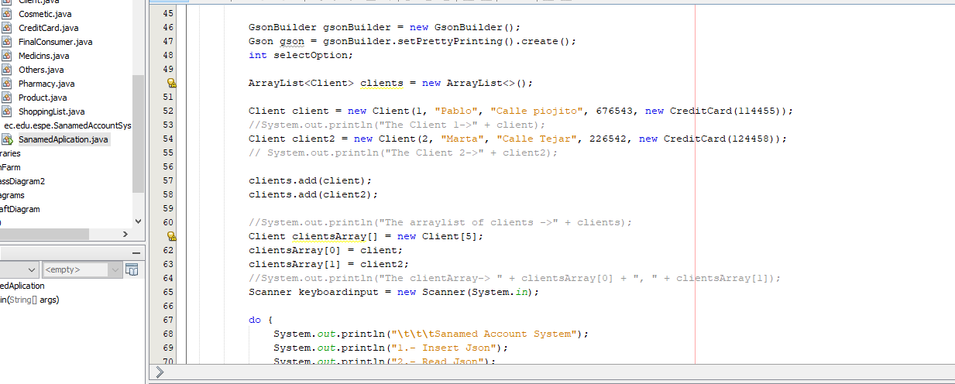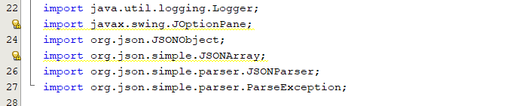

* Imported libraries that are not going to be used

7.-

* Messy code mixed with comments

8.-

* The program does not generate the json file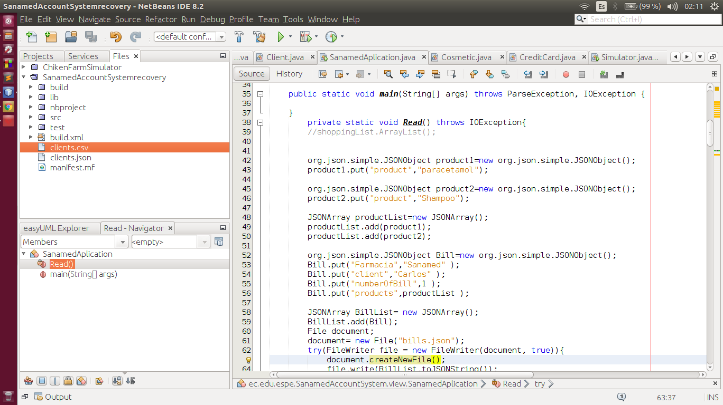

9. -

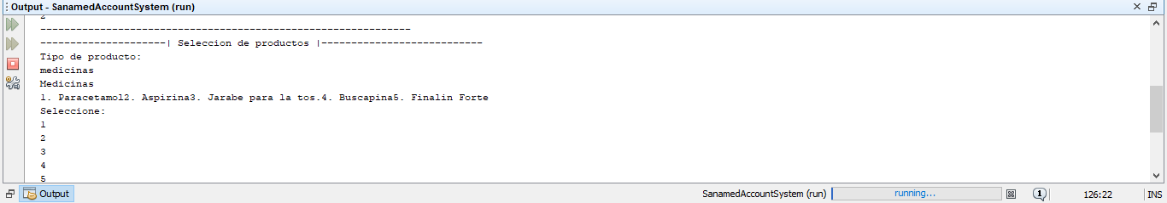

* Does not identify product options.

10.-

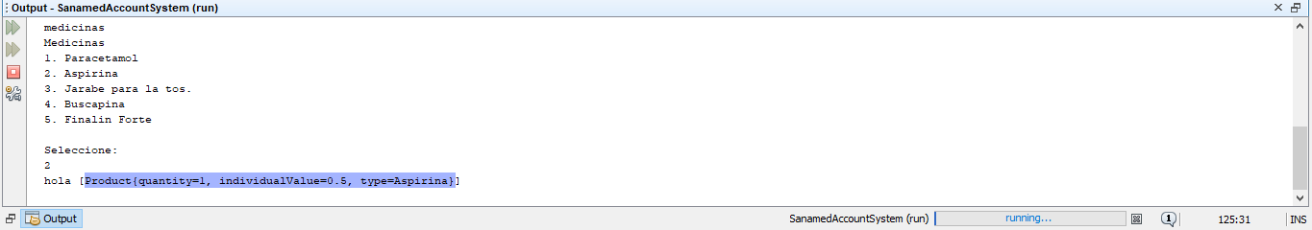

* The program stalls when adding a product or entering data incorrectly.